Information booklet “ The Fakkel”
Language class for students starting in Holland at primary school The Rinket
2019 -2020

Information booklet The Fakkel 2019-2020

General information:

The school
Bachstraat 20, 1962 BD Heemskerk
Postbus 78, 1960 AB Heemskerk
tel: 0251-231093
emailadres: rinket@tabijn.nl
www.fakkel.tabijn.nl
www.rinket.tabijn.nl
Director: Margriet de Boer

The Fakkel is a school for students from 6 to 12/13 years old that just arrived in Holland. When students from other countries come to Holland, learning the Dutch language is a first priority. Speaking and understanding Dutch is the basis for their integration, social contacts and school career.

The Fakkel has got 3 classrooms. Children who came to Holland less than a year ago receive education in the Dutch language and Dutch customs at our school.
In these 3 classrooms, divided in the younger middle and older children, there’s a maximum of 17 students each in order to give the student enough attention.

The teachers:
Fakkel onderbouw (youngest, 6 and up) Carmen Spijker en Corine de Graaf
Fakkel middenbouw (middle) Yaelle Vleugel
Fakkel bovenbouw (oldest upto 12/13) Guido Brouwer
Marjo Paauw

Purpose
Research has proved that it is best for children to attend special languageschools. Regular primary schools often have a larger amount of students. This makes it difficult for them to give a student that doesn’t speak Dutch enough attention. Learning how to speak, read and write in Dutch takes a lot of time and extra attention. It doesn’t suffice to just give them the textbooks of the regular classes. Special materials and knowledge is needed. These students need a lot of help to understand what to do. At the Fakkel we have lots of experience at teaching children Dutch and we have the right materials to do so.

Classes for newcomers
In Holland we use the word ‘nieuwkomer’ (translated newcomer) for children that enter our primary school system straight from abroad or children that come from elsewhere in Holland, but still don’t speak enough Dutch to enter regular classes. Condition is that they came to Holland less than 1 year ago and now live in Heemskerk, Beverwijk, Velsen-Noord, Ijmuiden, Castricum or Uitgeest.
The Fakkel is meant for children between the ages of 6 and 12/13. It’s also important that the children are ‘mature’ enough to start the reading and writing process.

Students from all over the world
‘Newcomers’ come to Holland for all different kinds of reasons. They can come from within or outside the EU. Their country can be at war, they can move to Holland because of their parents job or their parent can marry a Dutch resident.
We have had students from Afghanistan, Poland, Germany, Hungary, Bulgaria, Ireland, Brazil, Morocco, Somalia, Turkey, Iraq, Iran, Italy, Zambia, Dominican Republic, Spain, Czech Republic, Tibet, Syria and many other countries.

40 weeks
The Fakkel works with modules of 10 weeks. After attending the classes for 30 weeks, the students will spend the Wednesdays at their next school (we call this the motherschool). The purpose is to get adjusted to regular primary education and making friends at their new school.
After 40 weeks of classes (1 year) at the Fakkel, the students will transfer completely to their motherschool. This often is a school close to home.
Sometimes there are exceptions. There can be children that need a longer or shorter period to learn Dutch properly. Every child is different of course and has his own background as well.
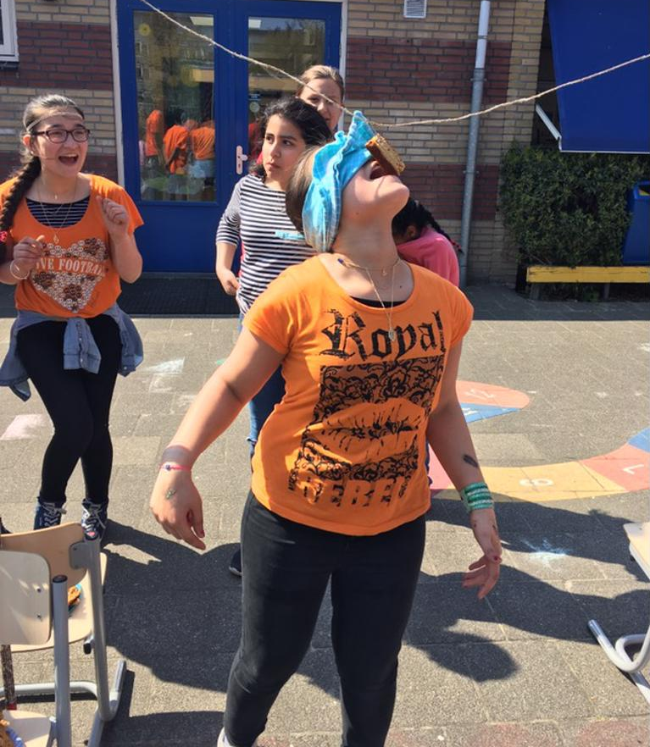
If we think we should make an exception, there will always be consultation with a external advisor and the parents to decide for how much longer the child will stay at The Fakkel to optimize his/her learning curve.

Level after 40 weeks of education
A periode of 1 or even 2 years of extensive language education will not suffice for a completely succesfull transfer to regular education. International research has proved that at least 5 years are necessary for a succesful integration, especially for older students.
At the time of transfer to the motherschool the students level will not be equal to the regular Dutch students.
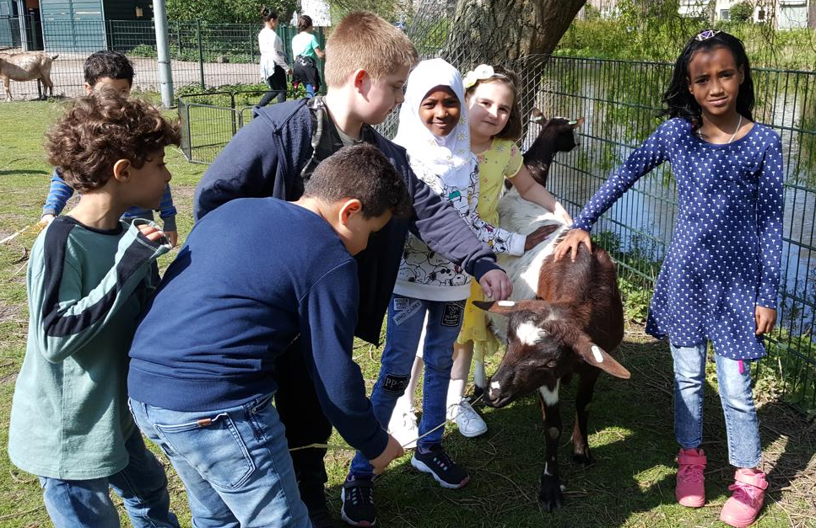
This level depends on the situation of the child. A child that has never been to school before and doesn’t know any letters will probably not be able to participate with the regular programme at the motherschool. Children who have already been to school in their native country more often get further along in the programme. The motherschool is obligated to continue the educational process at the level the student reaches when he/she leaves The Fakkel. The child’s intelligence and the domestic situation can also have a big influence on the learning pace of a child.

* Do you or your partner speak Dutch to the child
* Does your child visit the library and does he/she read at home as well?
* Does your child watch Dutch television?
* Did the child join a sportsclub?
* Does your child play with Dutch children?
These are all matters that can contribute to a fast learning pace in learning the Dutch language.

The teachers at The Fakkel will speak to the motherschool twice a year about the level of progress the student makes.

How to register at The Fakkel
Parents need to register their child at The Fakkel. To do so please make a appointment. It is also important to look for and talk to a motherschool, so that they know that the student will attend wednesdays at their school after 30 weeks of education. The teachers from The Fakkel will contact the motherschool about the trasferdate and class.
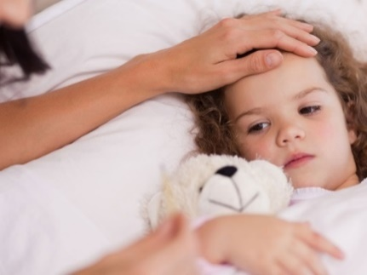
After leaving The Fakkel the student will be registered at the new school.

Calling in to report illness
If your child is ill, please let us know before 8:30 a.m. at 0251-231093. Does your child go to school by taxi? Please call them in time as well.

Leave
Children cannot just take a day off. There are special rules about asking for leave in Holland. You can ask for a form to ask permission at the headteacher’s office. In cases where children are absent without permission this will always be reported to the school attendance officer.

Transportation
Parents are responsible for the transportation of their children. You can ask for aid at the local district council. The district will only pay for a taxitransportation for 12 weeks.
Children that come to school by taxi will be picked up at their home address and in the afternoon they will be brought back to their home address. It is important that you call the taxi when your child is ill. You will get the correct telephone number from the taxicompany.

10:00 a.m. healthy snack
The children take a small break at 10:00 a.m. It would be nice if you give your child something healthy to eat and drink for this break. Not much, just a piece of fruit or a slice of bread and some milk will do. Please provide the snack with their name, so your child will know which one is theirs.

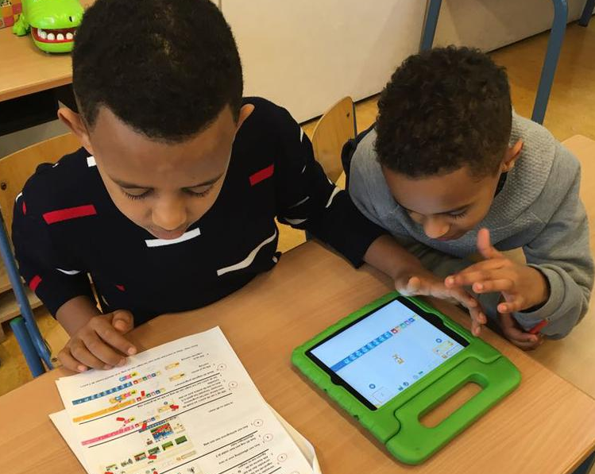
Lunch
All children have lunch at school in their classrooms with their teachers. After lunch the children will go outside to play under the supervision of ‘lunch mums’ and a school employee.
If it’s raining the children will play inside in their own classroom. After 15 minutes lunch and 30 minutes playtime the afternoon school programme starts.

We would like to encourage healthy foods and drinks. That is why we ask you to provide your child with healthy snacks and lunches.
It is not allowed for students to bring soft drinks, sweets or biscuits to school. If you give your child fruit to bring to school, please prepare this in such a matter that your child can peel/eat this by himself /herself.

Special activities
With school trips and other activities like Christmas or Saint Nicolas celebrations the children of The Fakkel will join the children of regular primary school Het Rinket.
If there is a celebration at the motherschool that the child wants to attend, arrangements can be made.
The students have gymnastics class 2 times a week on Mondays and Thursdays.
The student needs to bring a bag with sportswear on those days. For example jogging pants or shorts, a T-shirt, clean socks and sneakers with white soles.

What do we expect from parents?
We expect:
- that parents are involved in your childs education. You will get information through PTA meetings, appointments and (digital) newsletters. It’s important that you stay up to date with what is happening at school. You can, of course, always contact the teacher or yourself if there is something you want to talk about. Open communication with parents is very important to us.
- that parents make sure that their children are at school on time and that they are not absent without a good reason. Students miss classes if they are late or absent and they really need all the educational time they can get. At The Fakkel we even put in more hours at school for the children so they can achieve as high a level as possible.
- that parents value good progress as well and that they cooperate with the school to help the child achieve this.

Newsletter trough social schools
The digital newsletter comes out in the free app Social Schools. You will be informed about school business of all sorts and dates that are important for you to know.
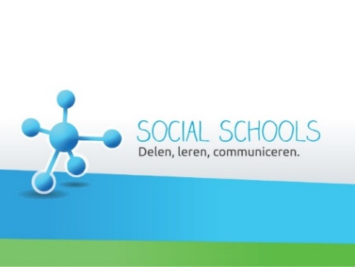
You can register for social schools on our website rinket.tabijn.nl (In the upperright corner). After registering the teacher will check if the registered person does indeed have a child at our school. After this check you will be able to check the newsitems on the ‘social schools’ app.
At the signing in or at the start of a school year you will receive a school calendar with all important dates like holidays.

Contact
We think it’s important that we can always reach someone in case a child is ill or has an accident. Please make sure that the teachers always have your current telephone number and if possible an extra number of, for example, a grandparent, aunt or babysitter.

School website
On the school’s websites fakkel.tabijn.nl you can find general information about the school.

Mobile phones
To prevent problems students are not allowed to have a mobile phone at school. Exceptions can be discussed with the headteacher. All phones that are brought to school will be taken by the teacher for the day.

End of the month performance
At the end of each month we have an ‘End of the month performance’. The children will perform something like a song or a poem they learned that month. Parents are welcome at these performances, when their child is performing. The dates and performing classes can be found in the schoolcalendar.

Allergies and medication
Because of birthday treats and celebrations it is important for us to know if your child has allergies. Please inform the teacher if your child uses medication as well.

GGD
The health service GGD will do a complete check-up of the children’s health, for example weight, eyes, ears, vaccinations.
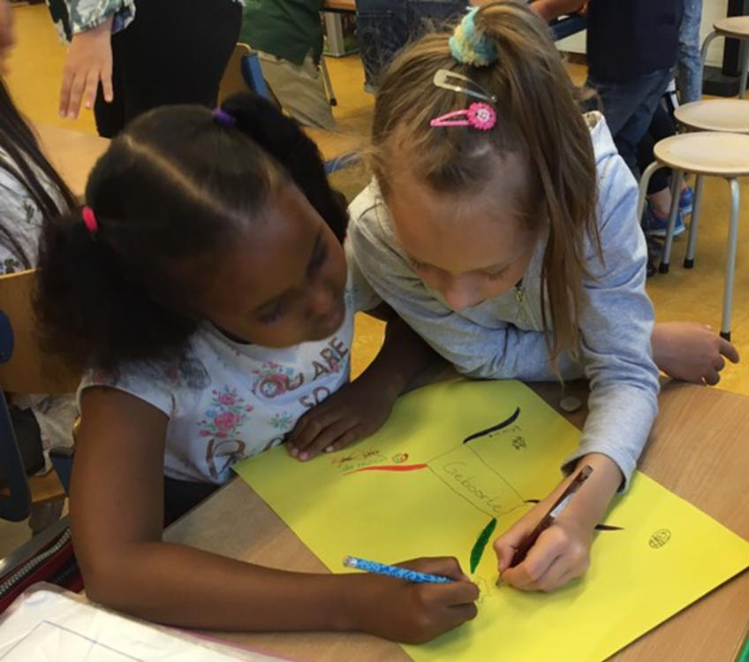
Regularly a group of ‘lice mothers’ will check all children for head lice. If they find head lice on your child, you will be notified by the teacher. Every child gets a free ‘anti-licebag’ to put their coat in, so we minimize the chances of spreading. Please let the teacher know if you find head lice on your child yourself, so we can check the other children.

Birthdays
Children who have their birthdays can give the children in their own class a treat. We ask you to give only one small thing. Treats that are too big will, at least partially, be given back home.

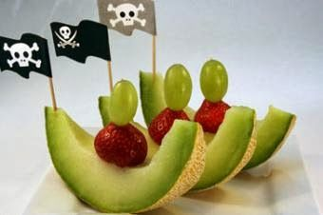

Social worker
There is a social worker appointed to the school. If you would like to make an appointment with her you can contact the teacher or our care supervisor Olga Hasenack.

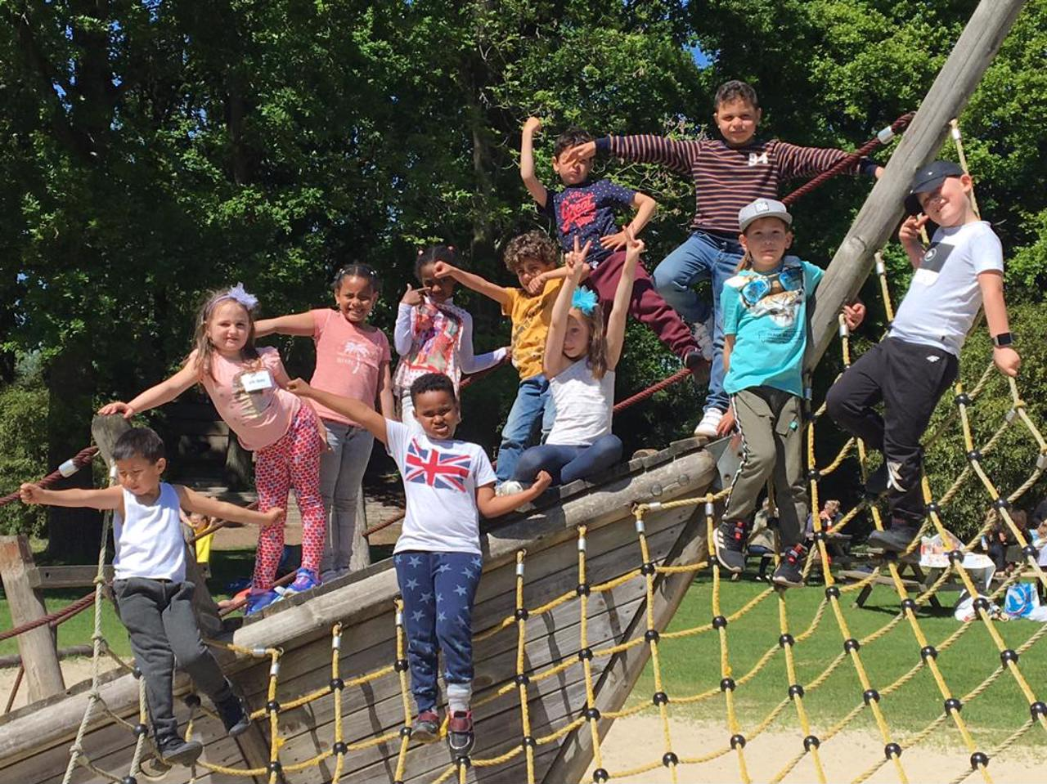
Holliday schedule The Rinket and The Fakkel 2019-2020

 | eerste dag | laatste dag
Autumn holiday | 21-10-2019 | 25-10-2019
Christmas holiday | 23-12-2019 | 03-01-2020
Spring holiday  Easter | 17-02-2020  10-04-2020 | 21-02-2020  13-04-2020
May holiday | 27-04-2020 | 08-05-2020
Acsesion day | 21-05-2020 | 22-05-2020
Whit Sunday | 01-06-2020
Summer holiday | 03-07-2020 | 17-08-2020

Study-days (the teachers study, the children have a day off)
28-10-2019
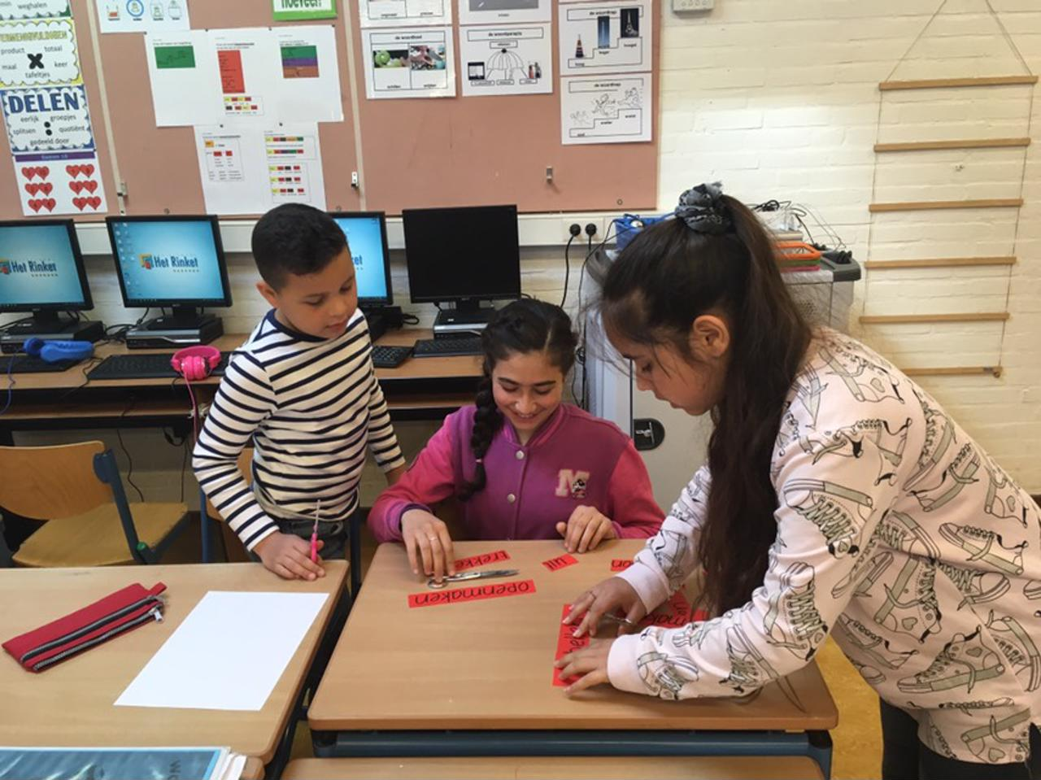
05-11-2019
23-01-2020
01-04-2020
14-4-2020
25-06-2020

Timetable
Monday 8.30 – 14:30
Tuesday 8.30 – 14:30
Wednesday 8.30 – 12.15
Thursday 8.30 – 14:30
Friday 8.30 – 14:30

Test weeks:
14-10-2019 18-10-2019
13-01-2020 17-01-2020
30-03-2020 03-04-2020
15-06-2020 19-06-2020

Moments for leaving to the motherschool
1euitstroom 11-11-2019
2e uitstroom 17-01-2020
3e uitstroom 03-04-2020
4e uitstroom At the end of the schoolyear

